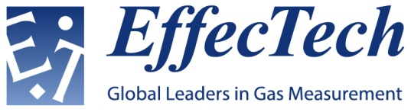
Quality Policy

EffecTech provides specialist products, support services and consultancy to the oil, gas and power industries in the measurement of gas quality, gas flow and total energy.

In support of all its activities EffecTech has established a quality system in accordance with the requirements of the following International Standards. EffecTech is committed to satisfying all applicable requirements including these International Standards

ISO/IEC 17025 - General requirements for the competence of testing and calibration laboratories

ISO/IEC 17043 - Conformity assessment - General requirements for proficiency testing

ISO/IEC 17020 - Conformity assessment - Requirements for the operation of various types of bodies performing inspection

ISO 9001 - Quality management systems - Requirements

EffecTech’s mission is to provide services to clients in a prompt and professional manner while adhering to the highest standards of safety, quality, and customer service. Quality objectives are established to support this mission.

EffecTech shall define key management responsibilities within the quality system in order to deliver this quality policy.

EffecTech shall carry out business professionally, competently and with due regard for the needs of the client. In doing so EffecTech shall protect, store and transmit appropriately all information deemed confidential and proprietary to the client.

EffecTech shall conduct business free from undue internal and external commercial and other pressures and influences that would diminish confidence in its competence, impartiality, judgement, and integrity.

The policies referred to in the quality manual apply to all work undertaken by EffecTech. EffecTech shall only provide services and products covered by the policies and principles laid down in this manual.

All EffecTech staff shall familiarise themselves with the quality manual and its related processes and implement the policies and procedures in their work.

EffecTech shall perform calibrations, tests, inspections and provide proficiency testing schemes in accordance with the policies, regulations, agreements, and procedures of the United Kingdom Accreditation Service (UKAS).

EffecTech aims to continually improve its quality system and therefore its service to customers through internal quality audits, management review, regular communication and feedback with staff and customers, and to implement and communicate these improvements effectively throughout the company.

Dr Gavin Squire  Chief Executive, EffecTech Group  Date 19 October 2017 | Alexandra Allsopp  Quality Manager

