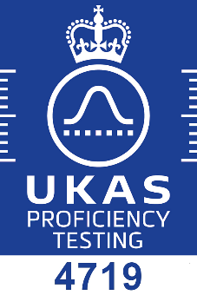
Stack Emissions Proficiency Testing Scheme (SEPTS) - Enrolment Form
EffecTech is accredited by the United Kingdom Accreditation Service (UKAS) to provide this
Proficiency Testing Scheme in accordance with the requirements of ISO/IEC 17043 : 2010

The scheme will run in May - August 2021, the closing date for enrolment is 04 April 2021
Participant Name / Company

Mixture Type | Price per item (EUR) | 2021
sulphur dioxide in nitrogen | 679
propane in 10% oxygen / nitrogen | 518
nitric oxide in nitrogen | 679
carbon monoxide in nitrogen | 518
oxygen in nitrogen | 518
carbon dioxide in nitrogen | 518
nitric oxide and nitrogen dioxide in nitrogen | 840
The prices above include the processing of one set of results per PT item.
If a participant wishes to submit an additional set of results to be included in the scheme a charge of €216 will apply. A maximum of one additional set of results can be submitted per PT item(s).
Additional set of measurements | Price  (EUR) | 2021
Second set of results for assessment | 216

Participant Project Manager
contact name
job title
email address
telephone number

Consignment Details (Good Inwards)
site contact name
delivery address

email address
telephone number

Accounting Details
invoice address
contact name
email address
telephone number
VAT registration number
preferred trading currency
Purchase Order Number

Terms and Conditions
EffecTech general terms and conditions apply (available on request)
Prices exclude VAT and all local taxes (if applicable)
Prices exclude door-to-door transportation costs
Payment terms are on receipt of invoice and prior to issue of final report
Refunds will not be given for failure to take part in any round of the scheme
Application of the protocol document is required
Signature
Date

