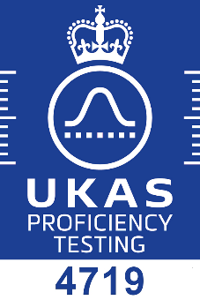
Stack Emissions Proficiency Testing Scheme (SEPTS) - Enrolment Form
EffecTech is accredited by the United Kingdom Accreditation Service (UKAS) to provide this
Proficiency Testing Scheme in accordance with the requirements of ISO/IEC 17043 : 2010

The scheme will run in May - August 2024, the closing date for enrolment is 01 April 2024
Participant Name / Company

Mixture Type | Price per item (GBP) | 2024
sulphur dioxide in nitrogen | 596
propane in 10% oxygen / nitrogen | 457
nitric oxide in nitrogen | 596
carbon monoxide in nitrogen | 457
oxygen in nitrogen | 457
carbon dioxide in nitrogen | 457
nitric oxide and nitrogen dioxide in nitrogen | 736
The prices above include the processing of one set of results per PT item.
If a participant wishes to submit an additional set of results to be included in the scheme a charge of £190 will apply. A maximum of one additional set of results can be submitted per PT item(s).
Additional set of measurements | Price  (GBP) | 2024
Second set of results for assessment | 190

Participant Project Manager
contact name
job title
email address
telephone number

Consignment Details (Good Inwards)
site contact name
delivery address

email address
telephone number

Accounting Details
invoice address
contact name
email address
telephone number
VAT registration number
preferred trading currency
Purchase Order Number

Terms and Conditions
EffecTech general terms and conditions apply (available on request)
Prices exclude VAT and all local taxes (if applicable)
Prices exclude door-to-door transportation costs
Payment terms are on receipt of invoice and prior to issue of final report
Refunds will not be given for failure to take part in any round of the scheme
Application of the protocol document is required
Signature
Date

