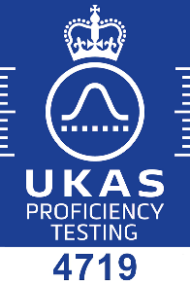
Global Gas and LNG Proficiency Testing Scheme - Enrolment Form
EffecTech is accredited by the United Kingdom Accreditation Service (UKAS) to provide this
Proficiency Testing Scheme in accordance with the requirements of ISO/IEC 17043 : 2010
Participant Name / Company

Mixture Type | Price per Round (Euro) | January 2022  (22Q1) | April 2022  (22Q2) | July 2022  (22Q3) | October 2022  (22Q4)
LNG composition | 1756
propane composition | 1696
MR composition | 1443
sulphur component mixture | 2133

Participant Project Manager
contact name
job title
email address
telephone number
fax number

Consignment Details
site contact name
delivery address
email address
telephone number
fax number

Accounting Details
invoice address
contact name
email address
telephone number
fax number
VAT registration number
preferred trading currency

Purchase Order Number

Terms and Conditions
EffecTech general terms and conditions apply (available on request)
Prices exclude VAT and all local taxes (if applicable)
Prices exclude any transportation costs
Payment terms are on receipt of invoice and prior to issue of final report
Refunds will not be given for failure to take part in any round of the scheme
Application of the protocol document is required

Signature
Date

